
ECHION HEALTH PRODUCT UPDATES DOCUMENTATION

Overview
This document outlines the required features and enhancements for the Echion Health platform. The goal is to improve AI-assisted reporting, template management, hospital customization, and user workflow efficiency.
1. AI-Generated Structured Reporting
Objective
Integrate OpenAI 4.0 Mini API/ Gemini API to generate structured medical reports.
Requirements
• Use OpenAI 4.0 Mini API / Gemini API for report generation.
• Implement prompt engineering to ensure outputs follow a structured reporting format.
• The structure should include:
• Findings
• Impression
• Recommendations (optional)

Backend Tasks
• Create API endpoint: /generate-report
• Accept inputs:
• Raw notes or transcript
• Report type (e.g., Abdomen, Pelvis, Abdomenoplevic Male, Abdomenopelvic Female, Obs, Breast, Doppler)
• Process input through OpenAI API
• Return structured JSON output

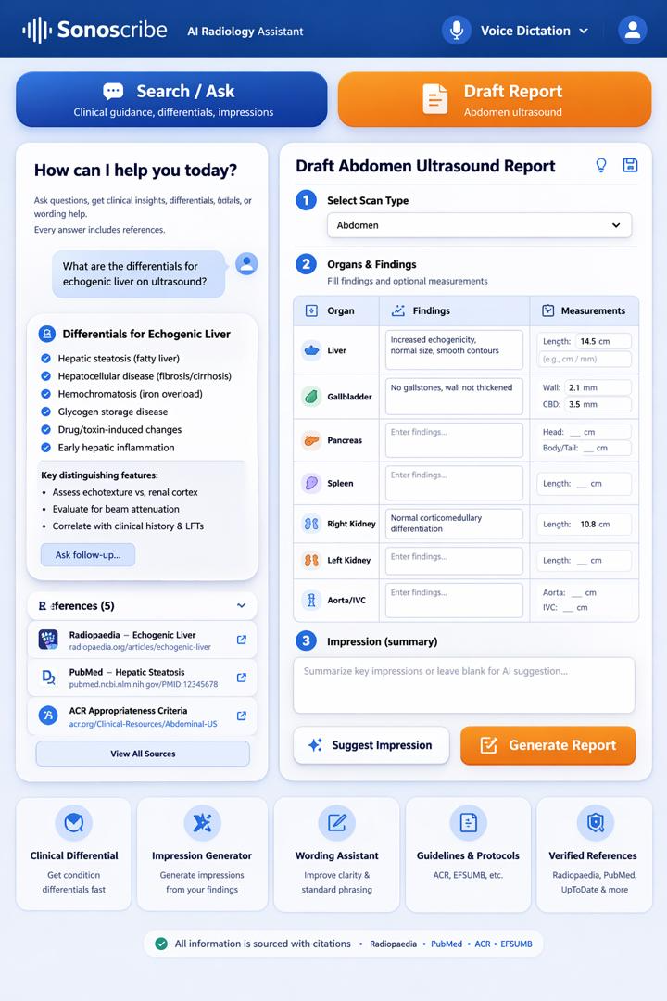
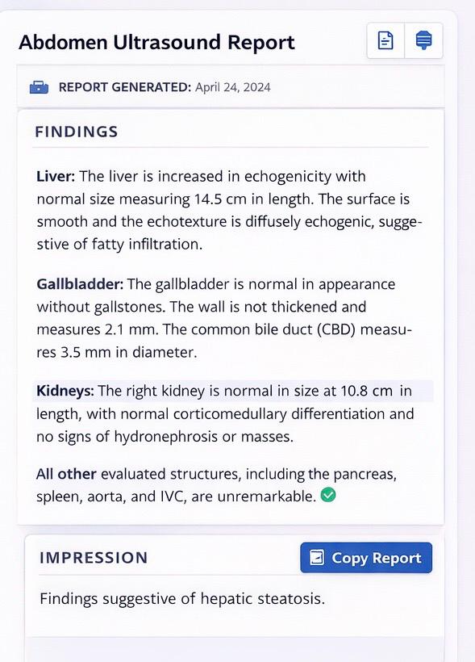

2. New report
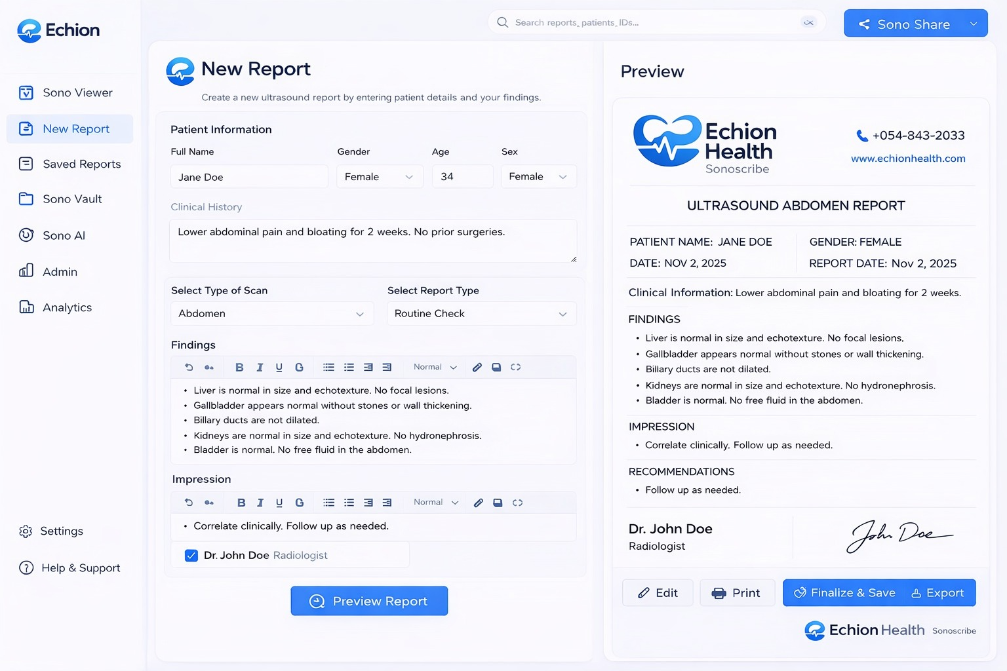

3. Save reports
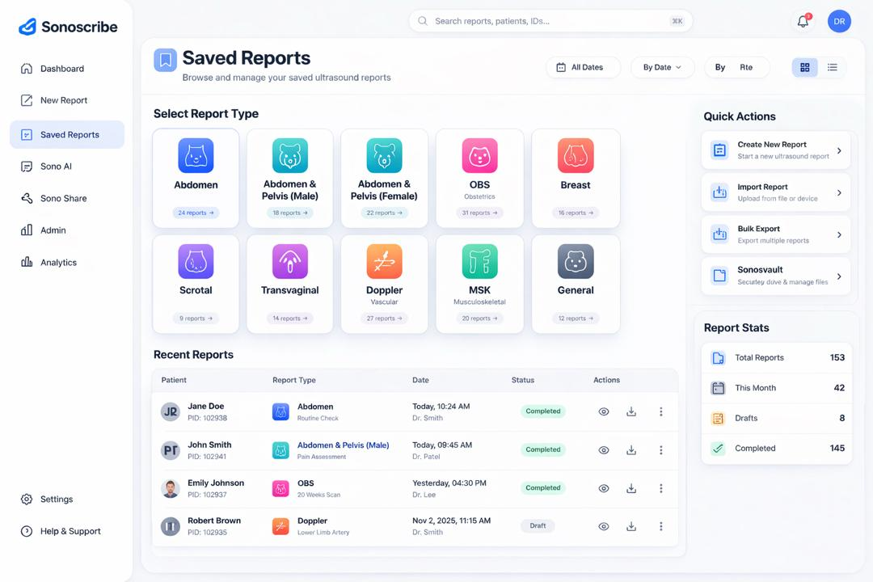

4. Template Storage & Organization (SonoVault )

Objective

Enable scalable storage and categorization of templates.
Requirements
• Add storage system for templates and reports.
• Group templates into report types:
• Abdomen
• Pelvis
• Obstetrics (OBS)
• Others (extendable)
• Ensure templates are accessible in Sonoscribe during reporting.

The Sonovault UI should look like this
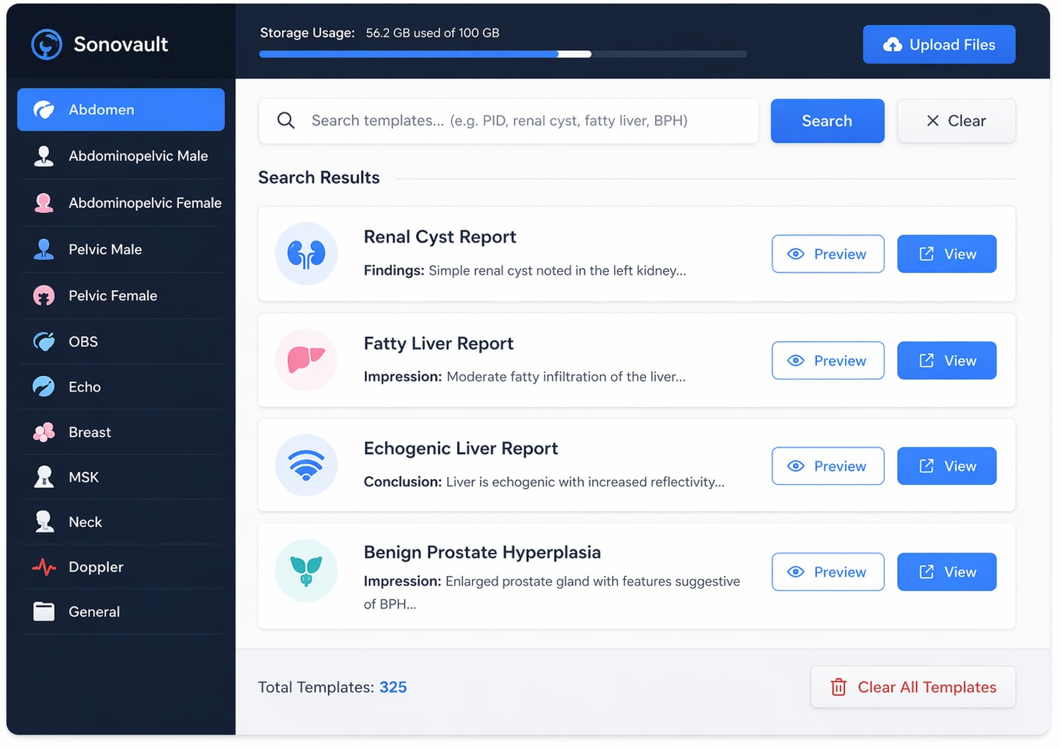

5. Hospital Header Customization

Objective

Allow hospitals to customize report headers.

Requirements
• Hospitals should be able to:
• Upload logo (optional)
• Enter hospital name
• Add address and contact details
• Header should automatically appear on generated reports.

Backend Tasks
• Create hospital_profile table:
• id
• hospital_name
• logo_url
• address
• contact_info
• Attach header metadata to report generation response.



The is the default report header for Echion Health hospitals or clinics can edit or upload their own header. Eit report heading etc.

New logo


6. Report Signature & Attribution

Objective

Include the reporting clinician’s identity.

Requirements
• Add fields for:
• Name of clinician
• Signature (text or image)
• Automatically append to reports.

Backend Tasks
• Extend users table:
• full_name
• signature_url
• Inject into final report output.

7. Multi-Tenant Authentication (Hospitals/Clinics)

Objective

Allow each hospital/clinic to operate independently.

Requirements
• During signup:
• Hospital selects or enters their organization name (e.g., “Echion Health”, “XYZ Clinic”)
• Create unique tenant environment
• Login flow:
• Username
• Password
• Associated with hospital

Backend Tasks
• Create organizations table:
• id
• name
• Update users table:
• username
• password (hashed)
• organization_id
• Authentication endpoints:
• /auth/signup
• /auth/login

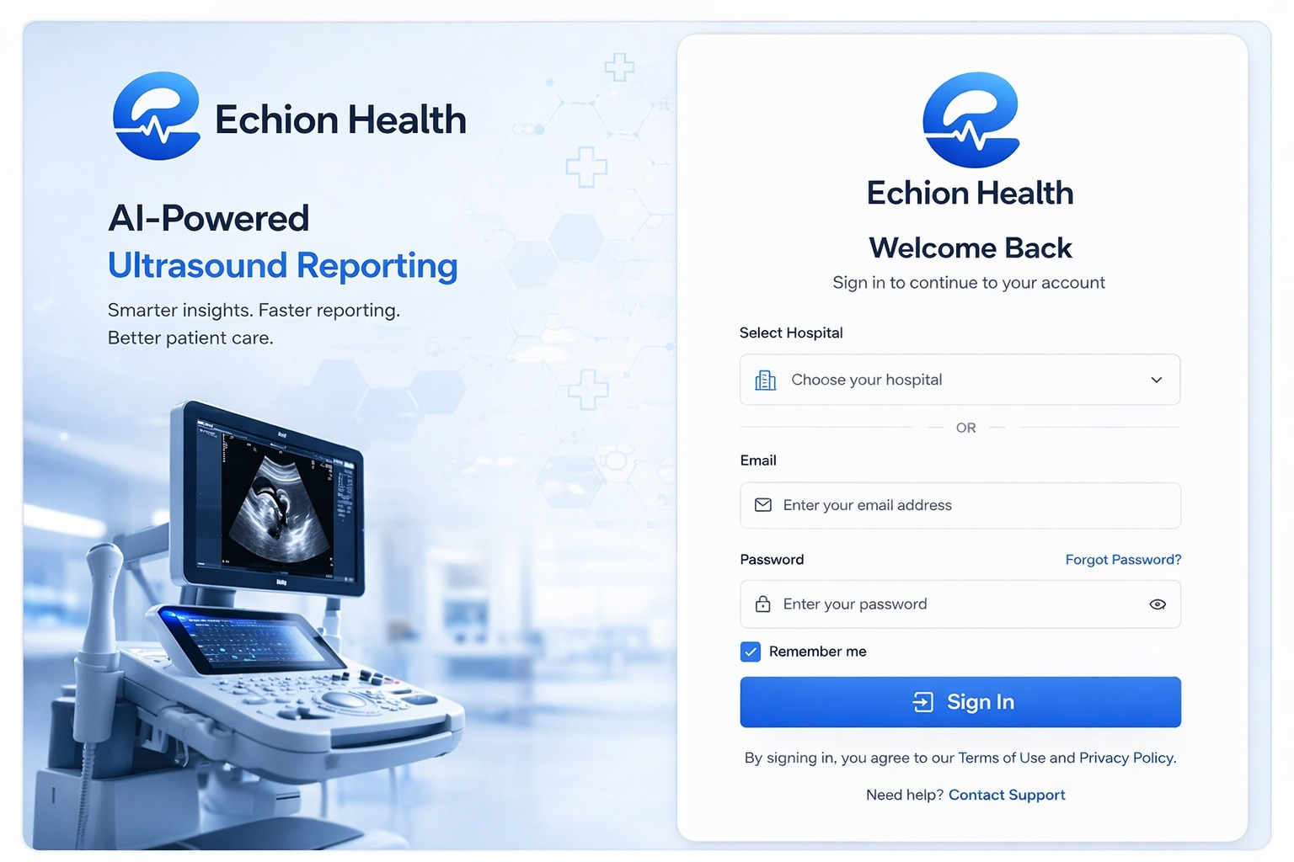

7. Bulk Upload to SonoVault

Objective

Enable fast onboarding by uploading multiple templates/reports at once.

Requirements
• Support bulk upload (CSV, JSON, or multiple files)
• Validate data before insertion
• Assign uploaded items to correct categories

Backend Tasks
• Endpoint: /templates/bulk-upload
• Implement:
• File parsing
• Validation
• Batch database insert

8. Improved Navigation (SonoVault Access)

Objective

Improve workflow without forcing logout.

Requirements
• Inside SonoVault:
• Add button: “Upload More Templates”
• Users should:
• Navigate directly to upload page
• Return to vault seamlessly

Backend Considerations
• Ensure session persistence
• No re-authentication required

9. Template Customization.
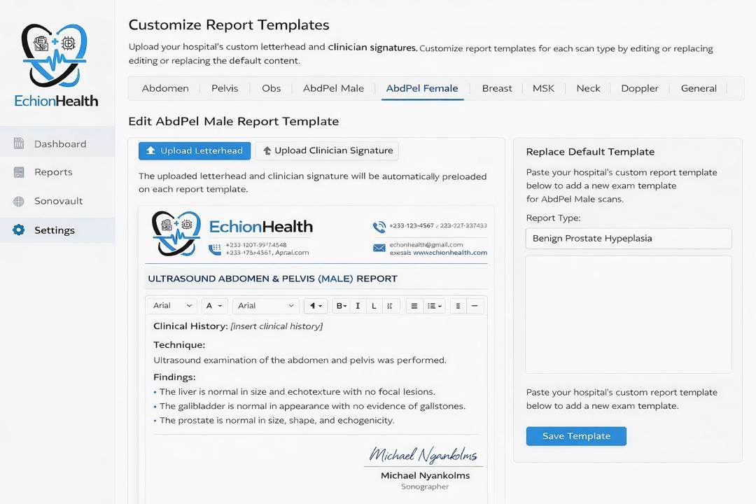
For the scan type use the following below for the customization of the templates
ABDOMINAL ULTRASOUND
ABDOMEN AND PELVIS (MALE)
ABDOMEN AND PELVIS (FEMALE)
PELVIC ULTRASOUND (MALE)
PELVIC ULTRASOUND (FEMALE)
OBSTETRIC
ANOMALY
BIOPHYSICAL PROFILE
TRANSABDOMINAL PELVIC ULTRASOUND
TRANSVAGINAL ULTRASOUND
ECHOCARDIOGRAPHY (ADULT ECHO)
PEDIATRIC ECHOCARDIOGRAPHY
MUSCULOSKELETAL ULTRASOUND
THYROID ULTRASOUND
BREAST ULTRASOUND
SCROTAL (TESTICULAR) ULTRASOUND
PENILE ULTRASOUND
ARTERIAL DOPPLER
VENOUS DOPPLER
GENERAL REPORT

